**Library Prep Using the “With-Bead” Method**

**Introduction**

This protocol is based on the method of Meyer and Kircher (2010) with modifications to accommodate the capturing of divergent species. The “with-beads” method is also adopted in this protocol to increase the complexity of the library (Fisher et al., 2011). Higher yield of the library was found when using the “with-beads” method than using the regular cleanup methods (Fig. 1).

\***For capturing multiplexed samples, such as many individuals from a population, we usually choose 500bp shearing size, do indexing PCR (inline) before pooling them together for capturing (see details in the text).**

a)

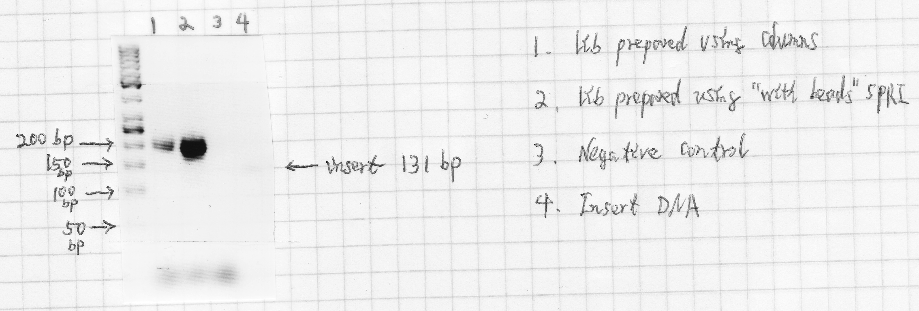

b)

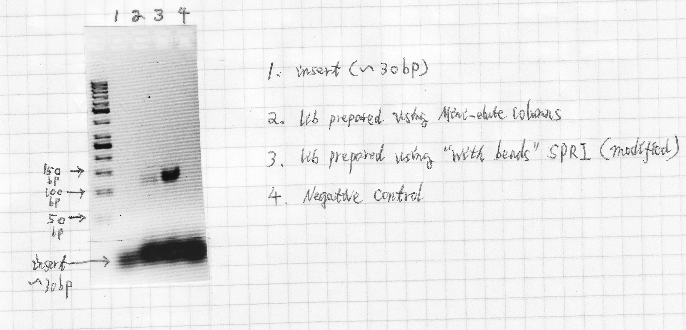

Fig.1. Comparison between “with-bead” library prep method and the common method using columns to cleanup the reaction after each step. a) library with insert size of 131 bp; b) library with insert size ~ 30 bp.

**N.B.**

*It is very important to avoid potential cross-contamination. The following tips should be followed:*

* *Clean your bench with bleach (84) every time after you did DNA extraction or fish dissection. Clean your pipettors, rack and bench space with bleach once a while.*
* *Aliquot all reagents into appropriate amount, so not to contaminate the whole tube of reagents.*
* *Make sure you have enough filtered tips, and never use tips without filter.*
* ***Centrifuge the tube every time before you open a lid.*** *Keep you finger off the inside of the lid. If you suspect that your gloves are contaminated, change it.*
* *Leave a space between tubes on rack, if you are not using multichannel pipettors.*
* *When pipetting, do it smoothly, don’t pump it too fast. Keep the tip submerged just under the solution, so not push the liquid to overflow.*
* *When adding samples, set the tip against the wall of the tube.*
* *Move your tubes to an up row or switch the orientation of your tubes after adding samples to keep track which one has been added to.*
* *Keep focused; don’t talk to others when they are working on sample prep.*

**Library prep procedure**

I. Shearing the genomic DNA

*Skip the shearing step if using samples with highly degraded DNA, e.g., ancient DNA or DNA extracted from museum samples.*

1. Start with 0.3 – 1 μg genomic DNA and shear it to ~ 250 bp range using the Covaris machine according to the instructions in “DNA Shearing on Covaris M220 with regular PCR tubes”.

*\* Use more DNA if available, e.g., 1 μg. Shear the DNA to ~ 500bp for multiplexing population level samples or if you want get longer flanking sequences.*

1. Centrifuge the tubes briefly. Check the size distribution of the sheared DNA on a mini agarose gel (optional).
2. Dry down the sheared DNA using MagNA beads following the protocol “DNA Clean-Up Using MagNA Beads” (take **100** μL of sheared sample). Add a positive (~300 bp DNA) and a negative (water) control through all the rest of the steps.

*\* Usually size selection is not necessary at this step, unless you want a more precise size range of the fragmented DNA.*

II. Blunt-end repair

*If working with ancient DNA or other samples with DNA fragment < 100 bp, skip the shearing step. Concentrate the DNA samples until dry using a speed vac. Then add 20 μL of the master mix to each sample as in the protocol below. After the blunt-end repair, skip step II-3. Instead, incubate the reaction at 75 °C for 20 min to deactivate the enzymes and followed by a ramp decreasing to 12 °C at the rate of 1 °C/s. Immediately proceed to the ligation step.*

1. Prepare a master mix for the number of samples needed as the follow.

|  |  |  |  |
| --- | --- | --- | --- |
| Reagent | Volume (μL)  per sample | × *n* | Final concentration  in 20-μL reaction |
| Buffer Tango (10×) | 2.2 |  | 1× |
| dNTPs (10 mM each) | 0.22 |  | 100 μM each |
| ATP (100 mM) | 0.22 |  | 1 mM |
| T4 polynucleotide kinase (10 U/μL) | 1.1 |  | 0.5 U/μL |
| T4 DNA polymerase (5 U/μL) | 0.44 |  | 0.1 U/μL |
| H2O | 17.82 |  |  |
| Total |  | ***No need to prep mix for extra samples*** | |

1. Add 20 μL of the master mix to each sample. Mix the sample well by pipetting 5-10 times smoothly.
2. Incubate the samples in a thermal cycler for 15 min at 25 °C followed by 5 min at 12 °C. **Spin down the liquid by brief centrifugation**.
3. Clean up the reaction according to the MagNA beads protocol (add appropriate amount of PEG buffer to the sample, **no need to add new beads**). Keep the dried beads.

*\*Proceed immediately to the ligation step.*

III. Adapter ligation

1. Prepare a master mix for the number of samples needed (inline adapters added later, if using regular adapters, add 1.1 μL of each adapter in the master mix).

|  |  |  |  |
| --- | --- | --- | --- |
| Reagent | Volume (μL) per sample | × *n* | Final concentration in 40-μL reaction |
| T4 DNA ligase buffer (10×) | 4.4 |  | 1× |
| PEG-4000 (50%) | 4.4 |  | 5% |
| Inline Adapter mix IS1 (50 μM each) |  |  | 1.25 μM each |
| Inline Adapter mix IS2 (50 μM each) |  |  | 1.25 μM each |
| T4 DNA ligase (5 U/μL) | 1.1 |  | 0.125 U/μL |
| H2O | 31.9 |  |  |
| Total |  | ***No need to prep mix for extra samples*** | |

*If working with ancient DNA or other samples with DNA fragments < 100 bp, add 11.9 μL of water instead of 31.9 μL as in the protocol above, then add 20 μL of master mixture to each sample.*

1. Added inline adapter mix IS1 and IS2, 1 μL of each to the sample tube according to sample sheet (skip this step and added 40 μL master mix to the tube if working with regular adapters)
2. Add 38 μL of the master mix to each sample tube. Mix the samples well by pipetting 5-10 times smoothly.
3. Incubate for 30 min at 22 °C in a thermal cycler. Spin down the liquid by brief centrifugation.
4. Cleanup the reaction using the MagNA bead method (add appropriate amount of buffer to the sample, no need to add new beads). Keep the dried beads. Proceed immediately to the next step.

IV. Fill-in

1. Prepare a master mix for the number of samples needed.

|  |  |  |  |
| --- | --- | --- | --- |
| Reagent | Volume (μL) per sample | × *n* | Final concentration in 40-μL reaction |
| Bsm buffer (10×) | 4.4 |  | 1× |
| dNTPs (10 mM each) | 1.1 |  | 250 μM each |
| Bsm polymerase, large fragment (8 U/μL) | 1.65 |  | 0.3 U/μL |
| H2O | 36.85 |  |  |
| Total |  | ***No need to prep mix for extra samples*** | |

1. Add 40 μL of master mix to the samples. Mix the samples well by pipetting 5-10 times smoothly. Incubate the samples for 20 min at 37 °C. Collect the liquid at the bottom of the tube by briefly centrifuging.
2. Cleanup the samples using the MagNA beads method. Add **35 μL** of TE buffer to each sample tube, keep the beads within the tube. Transfer the sample with the beads to a new tube labeled as “sample name + lib”.

*\*The libraries now can be kept frozen at -20 °C for a short period of time.*

V. Pre-hybridization PCR “with-beads”

1. Prepare a master mix as the follow for the number of samples needed.

|  |  |  |  |
| --- | --- | --- | --- |
| Reagent | Volume (μL) per sample | × *n* | Final concentration in 25-μL reaction |
| KAPA HiFi taq Ready Mix (2×) | 13.75 |  | 1× |
| Primer IS7 (10 μM) | 0.55 |  | 0.3 μM |
| Primer IS8 (10 μM) | 0.55 |  | 0.3 μM |
| Total | 14.85 | ***No need to prep mix for extra samples*** | |

1. Put the empty sample tubes on an iced box. Add 13.5 μL of master mix to empty tubes, and then add 11.5 μL of “lib” samples (take the **liquid mixed with beads** from the tube). Mix well and amplify the samples using the following thermal profile: 98 °C for 45 sec, **12 ~ 18** cycles of 98 °C for 15 sec, 60 °C for 30 sec and 72 °C for 45 sec, then followed by 72 °C for 1 min, and hold at 4 °C for 10 min. The number of PCR cycles can be adjusted according to the starting material used to construct the library.

*\*Keep the number of PCR cycles less than 18 cycles. Excessive amplification could increase the quantity of the PCR product but would also introduce more errors and bias.*

1. Cleanup the PCR product using the MagNA bead method [**add new beads and buffer**, because the high temperature (>90) in the PCR step may damage the coated layer of the previous beads]. Elute the DNA using 25 μL of TE buffer and transfer the supernant to a new tube labeled as “sample name + preH”.
2. Gel electrophoresis to check the amplified products, use 1 μL product.
3. Measure the concentration using Nanodrop3300. The concentration of the samples should be around 20 - 30 ng/μL. Store the preH product in -20 C.

*\*Do the preH PCR just before the next gene capturing step to avoid degradation of library DNA. Pool the individual samples equimolarly if working with multiplexing population level samples. Do not pool more than 24 samples in each tube.*

*Don’t do more than* ***32 samples*** *a time for lib prep and gene capture. Keep a list of index information for all samples. We have 24 pairs of inline index and 200 P7 index. After capture, each tube should be amplified with different P7 indexed adapter. Here is an example of sample list:*

|  |  |  |  |  |
| --- | --- | --- | --- | --- |
| Tube | Sample | P5 inline index | P7 inline index | P7 adapter index |
| 1 | 1 | IS1_1 | IS2_25 |  |
|  | 2 | IS1_2 | IS2_26 |  |
|  | 3 | IS1_3 | IS2_27 |  |
|  | 4 | IS1_4 | IS2_28 |  |
|  | 5 | IS1_5 | IS2_29 |  |
|  | 6 | IS1_6 | IS2_30 |  |
|  | 7 | IS1_7 | IS2_31 |  |
|  | 8 | IS1_8 | IS2_32 |  |
|  | 9 | IS1_9 | IS2_33 |  |
|  | 10 | IS1_10 | IS2_34 | index_8nt_27 |
|  | 11 | IS1_11 | IS2_35 |  |
|  | 12 | IS1_12 | IS2_36 |  |
|  | 13 | IS1_13 | IS2_37 |  |
|  | 14 | IS1_14 | IS2_38 |  |
|  | 15 | IS1_15 | IS2_39 |  |
|  | 16 | IS1_16 | IS2_40 |  |
|  | 17 | IS1_17 | IS2_41 |  |
|  | 18 | IS1_18 | IS2_42 |  |
|  | 19 | IS1_19 | IS2_43 |  |
|  | 20 | IS1_20 | IS2_44 |  |
| 2 | 21 | IS1_21 | IS2_45 |  |
|  | 22 | IS1_22 | IS2_46 |  |
|  | 23 | IS1_23 | IS2_47 |  |
|  | 24 | IS1_24 | IS2_48 |  |
|  | 25 | IS1_1 | IS2_26 |  |
|  | 26 | IS1_2 | IS2_27 | index_8nt_100 |
|  | 27 | IS1_3 | IS2_28 |  |
|  | 28 | IS1_4 | IS2_29 |  |
|  | 29 | IS1_5 | IS2_30 |  |
|  | 30 | IS1_6 | IS2_31 |  |
| 3 | 31 | IS1_7 | IS2_32 | index_8nt_208 |
| 4 | 32 | IS1_8 | IS2_33 | index_8nt_236 |
| 5 | 33 | IS1_9 | IS2_34 | index_8nt_336 |
| 6 | 34 | IS1_10 | IS2_35 | index_8nt_526 |
| 7 | 35 | IS1_11 | IS2_36 | index_8nt_527 |
| 8 | 36 | IS1_12 | IS2_37 | index_8nt_533 |
| 9 | 37 | IS1_13 | IS2_38 | index_8nt_685 |
| 10 | 38 | IS1_14 | IS2_39 | index_8nt_702 |
|  | … | … | … | … |
|  |  |  |  |  |
|  |  |  |  |  |

Make sure the base composition of the index is balanced for the inline index and the P7 adapter index. Use all 48 inline index and make different combination. If use less than 30 P7 index, try one of the following picks. If use more than 30 P7 index, use one of the 30 picks, and then add other index in a random order.

Here are some lists of 10 balanced P7 index:

Set I: 27, 100, 208, 236, 336, 526, 527, 533, 685, 702

Set II: 1, 2, 68, 432, 436, 442, 554, 647, 687, 693

Set III: 10, 138, 254, 423, 435, 440, 527, 551, 639, 679

Here are some lists of 15 balanced P7 index:

Set I: 1, 10, 89, 138, 254, 423, 435, 440, 527, 549, 551, 625, 639, 679, 711

Set II: 1, 10, 93, 233, 236, 285, 325, 517, 530, 533, 571, 654, 679, 687, 696

Set III: 2, 7, 9, 11, 288, 420, 435, 524, 526, 530, 559, 676, 684, 693, 695

Here are some lists of 20 balanced P7 index:

Set I: 1, 2, 4, 124, 130, 255, 347, 420, 434, 435, 441, 522, 526, 527, 547, 647, 668, 686, 691, 693

Set II: 2, 3, 12, 93, 138, 237, 255, 309, 388, 419, 527, 533, 549, 558, 589, 625, 639, 695, 706, 711

Set III: 1, 2, 7, 9, 11, 288, 335, 420, 431, 435, 524, 526, 530, 547, 559, 647, 676, 684, 693, 695

Here are some lists of 25 balanced P7 index:

Set I: 3, 7, 10, 13, 26, 200, 229, 235, 288, 325, 339, 381, 432, 487, 517, 522, 527, 530, 546, 609, 686, 687, 688, 703, 709

Set II: 1, 9, 20, 100, 129, 229, 332, 336, 383, 407, 421, 435, 440, 443, 513, 526, 527, 533, 546, 603, 628, 676, 684, 700, 706

Set III: 1, 8, 10, 11, 16, 129, 219, 254, 332, 334, 337, 362, 400, 517, 522, 526, 527, 565, 567, 654, 679, 683, 685, 691, 710

Here are some lists of 30 balanced P7 index:

Set I: 1, 7, 10, 16, 50, 100, 129, 130, 255, 336, 339, 383, 388, 419, 431, 513, 517, 526, 527, 533, 547, 588, 617, 633, 639, 650, 688, 693, 695, 707

Set II: 2, 3, 4, 7, 27, 89, 134, 229, 255, 303, 313, 332, 388, 435, 436, 527, 530, 533, 546, 571, 582, 587, 604, 609, 620, 638, 672, 686, 693, 707

Set III: 1, 2, 4, 13, 27, 208, 219, 229, 237, 332, 340, 389, 407, 431, 435, 438, 482, 515, 526, 527, 530, 554, 567, 603, 633, 647, 678, 686, 687, 693

**N.B.**

* *This step is very important, wear gloves and a mask, and spin it down after each mixing, be very careful with potential cross-contamination.*
* *Premix the oligo hybridization buffer (10x) with H2O according to 1 to 7 ratio; add 80 μL of the mixture into empty tubes. Then, add the adapters.*

**Recipe for adapter mix**

1. Assemble the following hybridization reactions in separate PCR tubes:

Hybridization mix for adapter P5 (50 μM, labeled as IS1_index):

|  |  |  |
| --- | --- | --- |
| Reagent | Volume (μL) | Final concentration in 100-μL reaction |
| IS1_adapter_P5.F (500 μM) | 10 | 50 μM |
| IS3_adapter_P5+P7.R (500 μM) | 10 | 50 μM |
| Oligo hybridization buffer (10×) | 10 | 1× |
| H2O | 70 |  |

Hybridization mix for adapter P7 (50 μM, labeled as IS2_index):

|  |  |  |
| --- | --- | --- |
| Reagent | Volume (μL) | Final concentration in 100-μL reaction |
| IS2_adapter_P7.F (500 μM) | 10 | 50 μM |
| IS3_adapter_P5+P7.R (500 μM) | 10 | 50 μM |
| Oligo hybridization buffer (10×) | 10 | 1× |
| H2O | 70 |  |

2. Mix and incubate the reactions in a thermal cycler for 10 sec at 95 °C, followed by a ramp from 95 °C to 12 °C at a rate of 0.1 °C/sec. [The original recipe (Meyer and Kircher, 2010) uses 200 μM for each adapter, we change it to 50 μM to save the cost].

3.Aliquot the mixture to different set of tubes (20 μL each), keep them at -20 °C.

**Recipe for oligo hybridization buffer (10X)**

|  |  |  |
| --- | --- | --- |
| Reagent | Volume (μL) | Final concentration in 10 ml |
| NaCl (5 M) | 1 ml | 500 mM |
| Tris-Cl, pH 8.0 (1 M) | 100 μL | 10 mM |
| EDTA, pH 8.0 (0.5 M) | 20 μL | 1 mM |
| H2O | 8.88 ml |  |

**Sequences of adapters, and primers**

|  |  |
| --- | --- |
| Name | Sequences |
| IS1_adapter.P5 | a*c*a*c*TCTTTCCCTACACGACGCTCTTCCg*a*t*c*t |
| IS2_adapter.P7 | g*t*g*a*CTGGAGTTCAGACGTGTGCTCTTCCg*a*t*c*t |
| IS3_adapter.P5+P7 | a*g*a*t*CGGAa*g*a*g*c |
| IS4_indPCR.P5 | AATGATACGGCGACCACCGAGATCTACACTCTTTCCCTACACGACGCTCTT |
| IS5_reamp.P5 | AATGATACGGCGACCACCGA |
| IS6_reamp.P7 | CAAGCAGAAGACGGCATACGA |
| IS7_short_amp.P5 | ACACTCTTTCCCTACACGAC |
| IS8_short_amp.P7 | GTGACTGGAGTTCAGACGTGT |
| IS4_n (P5) | AATGATACGGCGACCACCGAGATCTACACxxxxxxxxACACTCTTTCCCTACACGACGCTCTT |
| index_8nt_n (P7) | CAAGCAGAAGACGGCATACGAGATxxxxxxxxGTGACTGGAGTTCAGACGTGT |

**Inline barcodes**

|  |  |
| --- | --- |
| Name | Sequences |
| IS1_Ind1 | A*C*A*C*TCTTTCCCTACACGACGCTCTTCCGATCTtc*t*g*c*c |
| IS3_Ind1 | ggcagaAGATCGGAA*G*A*G*C |
| … |  |
|  |  |
| IS2_Ind25 | G*T*G*A*CTGGAGTTCAGACGTGTGCTCTTCCGATCTga*c*c*t*t |
| IS3_Ind25 | aaggtcAGATCGGAA*G*A*G*C |
| … |  |

* indicates a PTO bond

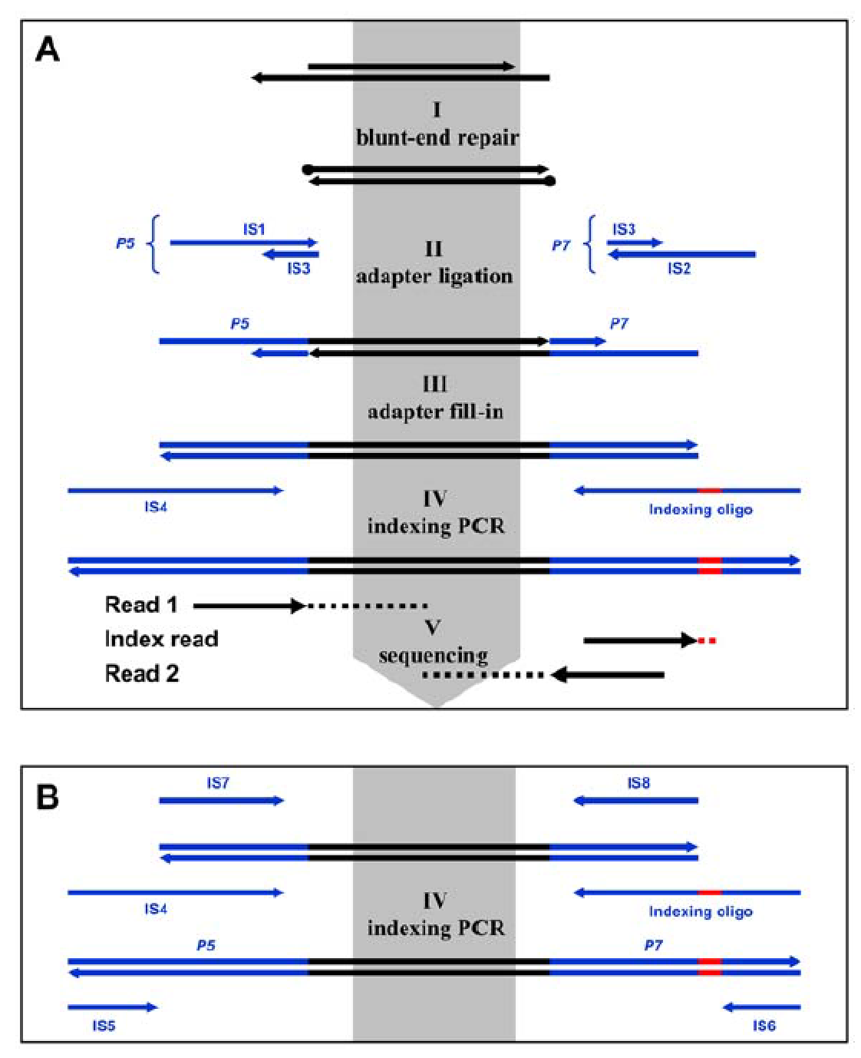

**C**

::::myfiles:SOU:水生系:GeneCaptureWorkshop:lib.pdf

IS1_index IS2_index P7 index

Fig.2. Schematic overview of the protocol and alternative amplification schemes (Meyer and Kircher, 2010). C shows the inline index (red).