N.B.
It is very important to avoid potential cross-contamination. The following tips should be followed:
- Clean your bench with bleach (84) every time after you did DNA extraction or fish dissection. Clean your pipettors, rack and bench space with bleach once a while.
- Aliquot all reagents into appropriate amount, so not to contaminate the whole tube of reagents.
- Make sure you have enough filtered tips, and never use tips without filter.
- Centrifuge the tube every time before you open a lid. Keep you finger off the inside of the lid. If you suspect that your gloves are contaminated, change it.
- Leave a space between tubes on rack, if you are not using multichannel pipettors.
- When pipetting, do it smoothly, don’t pump it too fast. Keep the tip submerged just under the solution, so not push the liquid to overflow.
- When adding samples, set the tip against the wall of the tube.
- Move your tubes to an up row or switch the orientation of your tubes after adding samples to keep track which one has been added to.
- Keep focused; please don’t talk to others when they are working on sample prep.

DNA Shearing on Covaris M220 with regular PCR tubes

Introduction
The Covaris microTUBE, such as the Screw-Cap 6x16mm (#520096, left in the figure below), is specifically designed and engineered for compatibility with Focused-ultrasonicator utilizing AFA technology. The microTUBE are made of a special borosilicate glass for low impedance and better transmission of acoustic energy. The integrated AFA fiber helps nucleation of cavitation bubbles and allows more uniform sample processing.
Nevertheless, regular thin wall 0.2 ml PCR tubes, such as Sorenson tube (#16950, middle in the figure) also could be used for DNA shearing. We have tested shearing DNA to ~250bp and ~500bp fragments using regular PCR tubes. The results are comparable, but the sheared DNA has a little wider range using the regular PCR tubes than using the microTUBEs.
However, PCR tubes cannot fit all the way down into the center hole of the Covaris® M220 microTUBE Holder (#4482279). So if you have a spare microTUBE Holder, you can use a round file to make the hole a little larger to fit the tube. But if you don’t want to alter the Holder, PCR tubes still can be used to shear DNA but with higher duty factor values (see parameter setting).

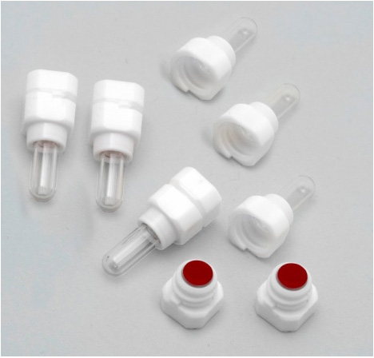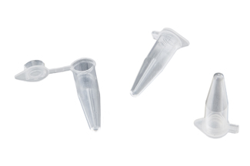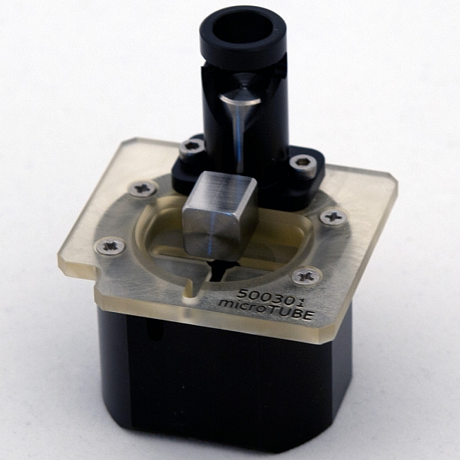

Fig. 1. microTUBE, regular pcr tubes and microTUBE holder used in DNA shearing

Parameter setting
- Set the temperature as 18 – 22 ˚C.
- Add a 30 second delay between any repeat treatments.
- There are four parameters that could be tuned to obtain preferred results: Peak Incident Power (PIP), Duty Factor (DF), Cycles per Burst (CB) and Duration (D).
- We choose the parameters used in lane5 for shearing DNA to 250bp (protocol name on our machine is 250bp_pcr_tube), the parameters used in lane2 for shearing DNA to 500bp (protocol name on our machine is 500bp_pcr_tube), using the altered microTUBE Holder (table 1, Fig. 2).
* We usually shear the genomic DNA to 250bp for most project, but sometimes shear the DNA to 500bp for population genetic or phylogeographic studies, when longer fragments could give us more sequence reads from the flanking region of the target genes.
- The parameters used in lane9 can be used for shearing DNA to 500bp and the parameters used in lane10 can be used for shearing DNA to 250bp using unaltered microTUBE holder (table 1, Fig. 2).
- It is ok that only part of the tube fit into the center hole of the unaltered microTUBE Holder.
- Add 270 μL samples for each shearing.
*Important, adding 270 μL of sample to avoid air layer formed on the bottom of the tube when shearing that could separate the sample and result in unevenly sheared DNA size. An air layer still may form as a top layer of tube, which is ok.
- Clean outside of the tubes with tissue paper after shearing, and then quick spin the tube before open the lid of the PCR tubes.
*be very careful to avoid cross contamination

Table 1. Parameters for shearing DNA using 0.2 ml PCR tubes.

Lane | PIP (w) | DF (%) | CB | D (sec) | Repeats | TUBE Holder
1 | 50.0 | 20 | 200 | 60 | 2 | altered
2 | 50.0 | 25 | 200 | 60 | 2 | altered
3 | 50.0 | 30 | 200 | 60 | 2 | altered
4 | 50.0 | 25 | 200 | 90 | 1 | altered
5 | 50.0 | 25 | 200 | 90 | 2 | altered
6 | Control, using microTUBE and default parameters for 500bp DNA |  |  |  |  | unaltered
7 | Control, unsheared DNA
8 | 50.0 | 25 | 200 | 90 | 2 | unaltered
9 | 50.0 | 30 | 200 | 60 | 2 | unaltered
10 | 50.0 | 35 | 200 | 90 | 2 | unaltered

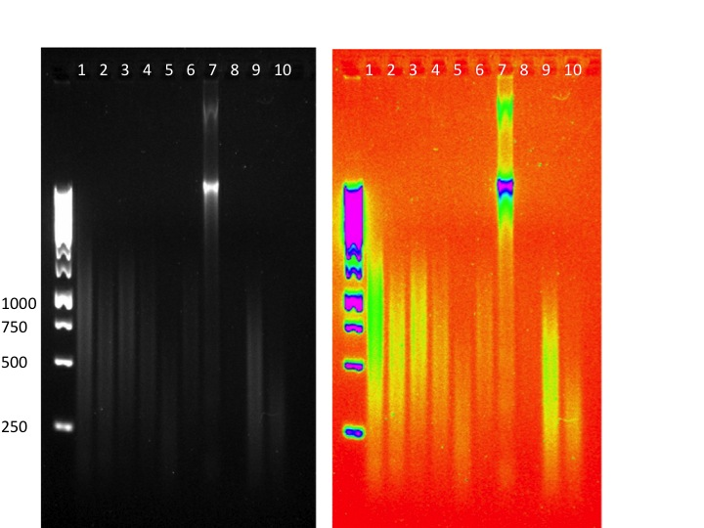

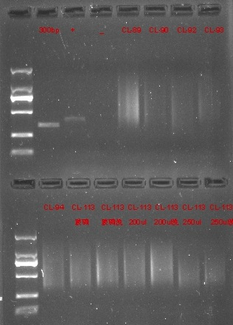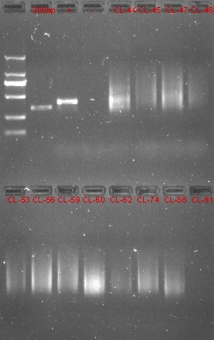

Fig. 2. Size of sheared DNA with different parameter setting and microTUBE holder (top); libraries made from sheared DNA (bottom).

