1. 参考图片中的示例，根据下面的对齐数据构建一个隐马尔可夫模型。

Build a hidden Markov model on the alignment below and following the example showing in the picture.

A C A T T C G C G

A - - - - C G C G

T C A A T G A C C

A - - - T G G T G

A G C - A G G T G

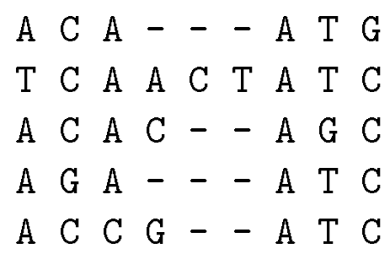

1. 为什么Illumina测序只能用于获取短读长，而第三代测序可以用来测序长读长序列？

Why Illumina sequencing can only be used for getting short reads? but the third-generation sequencing can be used to sequence long reads?

1. 围棋有19\*19 = 361个落子点，两种棋子，加上空位，则有3^361种可能的局面，远远超过宇宙原子的数量，然而Alpha Go/AlphaGo zero可以在这些可能性中找出下一步落子胜率最高的位置。在这个过程中使用了哪些方法？如何不依赖人类的棋局提高胜率？请简单描述过程。

Go has 361 points for placing stones on a 19x19 board, with two types of stones and empty spots, leading to3^361 possible board configurations, which far exceeds the number of atoms in the universe. However, AlphaGo and AlphaGo Zero can identify the move that has the highest winning probability among all these possibilities. What methods were used in this process? How did they improve winning chances without relying on human games? Please describe the process briefly.

1. 已知卷积神经网络的原理是矩阵对位相乘，各值求和，请给出一个矩阵可以同时识别自己学号的后两位，给出识别数字的计算结果，以及识别其他任意一个数字的结果。（矩阵大小任意，值为0~9的整数。数字图片转化为矩阵时，矩阵包含0和9。示例仅包含一个结果，需要给出三个）

It’s known that the principle of convolutional neural networks involves element-wise multiplication of matrices followed by summing the values. Please provide a matrix that can recognize the last two digits of your student ID, along with the calculation results for recognizing that number and for recognizing any other arbitrary digit. (The matrix size can be anything, with integer values from 0 to 9. When converting digit images to matrices, the matrices should include 0 and 9. The example contain only one result, but three need to be provided.)

示例(example)：

